Trinitrotoluene (TNT)

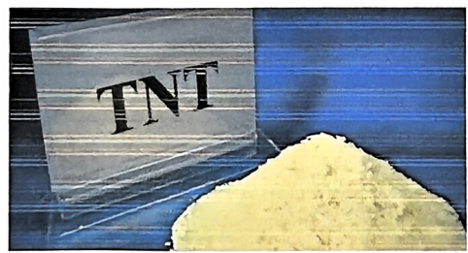

Testing Project | Product Analysis | Color | Yellow needle-like crystals
Odor | Qualified | UN Number | 0209
 | Quality Indicators
Project | Indicator | Test Value | Testing Basis | Determination Standard
Melting Point(Freezing Point) | 81℃ | 80.9℃ | GJB2005-6 | Qualified
Density | 1.654g/cm3 | 1.653g/cm3 | GJB2005-52 | Qualified
Boiling Point | 240℃ | 240℃ | GJB2005-7 | Qualified
Oxygen Balance | -74.0% | -74.0% | GJB2005-81 | Qualified
Vapor Pressure | 0.046mmHg（82℃） | 0.0458mmHg（82℃） | GJB2003-9 | Qualified
Solubility | Soluble In water, ethanol, and ether, soluble in chloroform, benzene, toluene, and acetone | Slightly soluble in water, ethanol, and ether, soluble in chloroform, benzene, toluene, and acetone | GJB2003-11 | Qualified

Molecular Structure Data
Molar Refractive Index | 50.71 | 50.72 | GJB2004-16 | Qualified
Molar Volume（cm3/mol） | 141.2 | 141.1 | GJB2004-2 | Qualified
Surface Tension（dyne/cm） | 71.9 | 71.88 | GJB2004-4 | Qualified
Polarization（10-24cm3） | Rate 20.10 | 20.10 | GJB2004-8 | Qualified
Surface Charge | 0 | 0 | GJB2006-10 | Qualified
 | Quality Indicators
Project | Indicator | Test Value | Testing Basis | Determination Standard
Hydrogen Bond Donor Count | 0 | 0 | GJB2006-10 | Qualified
Number of Tautomeric Forms | 0 | 0 | GJB2006-18 | Qualified
Determine Atomic Configuration in Number of Centers | 0 | 0 | GJB2006-20 | Qualified
Uncertain Chemical Bonding Number of Centers in Structure | 0 | 0 | GJB2006-16 | Qualified

