CS/BRE1 Type 122mm 40km Rocket Projectile
I. Weapon Compatibility
The Type 81, Type 89, Type 90A, and Type 90B 122mm rocket launchers, along with the BM-21 rocket launcher, are equipped with corresponding firing tables for these artillery systems.
II. Major Tactical and Technical Indicators
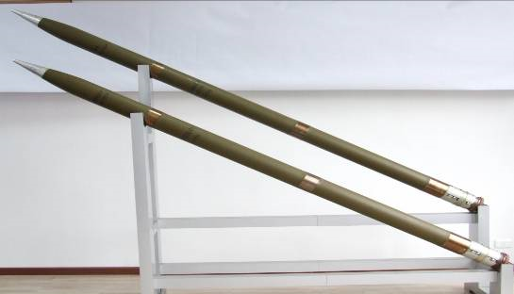
Figure: Appearance of CS/BRE1-type 122mm 40km Rocket Projectile
III. Main Applications
This weapon is primarily designed to eliminate and suppress enemy combat forces, technical equipment, fire support installations, surface vessels, and engineering facilities through sudden, intense firepower strikes. The warhead contains steel projectiles that significantly increase the number of effective fragmentation particles, thereby enhancing destructive capabilities against enemy troops. Characterized by long range, powerful firepower, user-friendly operation and maintenance, as well as low operational costs, it delivers comprehensive combat effectiveness.
IV. Technical Parameters
- Type and weight of projectile charge: 5.2kg TNT/RDX explosive;
- Type of warhead and total mass: Blast-type, 20.5 kg;
- Propellant: 26.35 kg;
- Fuze: CS/MC4 mechanical trigger fuze;
- Maximum range: ≥40 km;
- Density index: longitudinal ≤1/140, transverse ≤1/80;
- Critical radius: ≥45m;
- Bullet length (unfired state): 2752–2768 mm;
- Ballistic weight (unfired state): 67–69 kg;
- Operating temperature: -40℃ to +50℃;
- Storage duration: 10 years.
V. Packaging Requirements
External packaging materials and product quantity: 1 unit of inner packaging in fiberglass reinforced plastic (FRP) cylinder, 2 units of outer packaging in iron cage.
Package dimensions: 2890mm × 450mm × 250mm.
Total package weight: 200kg.

